
LIGUDU LUTENDO EVA ST10526509
WEDE5020

August 1, 2026
GROUP 7
[Company address]

Website project proposal -Sweet Crumbs Pops Bakery

  - Target Organisation
Name: Sweet Crumbs Pops Bakery
Type: Small business
Industry: Bakery
Location: South Africa,Pretoria

For this project,I chose Sweets Crumbs Pops Bakery as my target organisation .It is a small bakery that sells different types of baked products such as cakes,cupcakes,bread,cookies and pastries. The bakery needs a website because most people now use the internet to find businesses and products.Having a website will make it easier for customers to see what the bakery sells and find out how to contact them.

The website will be simple,attractive and easy to use.Customers should be able to find information without struggling or clicking through too many pages.

RESEARCH and PLANNING

2.1 Website Project Propsal
The main idea of the website is to give Sweet Crumbs Pops Bakery its own place online.At the moment, a small bakery may depend mostly on social media and people who already know about the business. I want the website to be easy to understand because not everyone is good with technology. A customer should be able to visit the website and quickly find what they are looking for.

GOALS OF THE WEBSITE:
The main goals of the website are:
- To help more people know about Sweet Crumbs Pop Bakery
- To show customers the products that the bakery sells
- To make it easier for customers to contact the baker
- To give customers information about the products and prices
- To help the bakery get more customers and orders
- To make the baker look more professional online.

TARGET AUDIENCE:
The website will mainly be foe people who are interested in buying baked products.
These can include:
- People from the local community
- Parents and families
- Students and Workers
- People looking for birthday cakes
- People planning for events/parties
- Anyone who wants to order cakes,cupcakes and other baked products

3. ORGANISATION OVERVIEW

Name of organisation: Sweet Crumbs Pops Bakery

About the organisation:
Sweet Crumbs Pops Bakery is a small bakery that makes and sells fresh baked products.The bakery sells normal everyday products as well as products for special occasions.

For example,a customer can order a cake for a birthday or cupcakes for a party.

MISSION:
The bakery’s mission is to make fresh and tasty products while giving customers friendly service.

VISION:
The bakery wants to grow and become one of the trusted bakeries in the local community.

TARGET CUSTOMERS:
The main customers will be local people,families,students.workers and anyone who needs baked products for themselves or for an event.

4.WEBSITE GOALS AND OBJECTIVES

The website will:
- Tell people more about Sweet Crumbs Pops Bakery
- Show the products that are available
- Make it easier for customers to contact the bakery
- Get more enquiries and orders
- Make the bakery look more professional

HOW I WILL KNOW IF THE WEBSITE IS SUCCESSFUL

I can check if the website is successful by looking at things such as:
-How many people visit the website
- How many orders come through the website
- Which products people look at the most
- Customer feedback about the website
If more people are finding the bakery and making enquires or orders ,then the website will be doing its job.

5. CURRENT WEBSITE SITUATION
Sweet Crumbs Pops Bakery does not currently have a proper website.The bakery can use social media to advertise its products,but social media is not always the easiest place for customers to find specific information.
For example,a customer might want to know the price of a cake but has to scroll through many posts or send a message to ask. This can be frustrating for the customer.

PROPOSED SOLUTION:
I would create a website where all the important information is kept together.
Customers will be able to visit the website and see the products,pictures,prices,business information and contact details without having to search through different social media posts.

6.PROPOSED WEBSITE FEATURES
The website will have different pages,with each page having its own purpose

- HOME PAGE
The home page will be the first page that the customer see.It will have a short introduction about the Sweet Crumbs Pops Bakery and some pictures of the products.
There will also be buttons that take customers to the product and contact pages.
- About us page
The about us page will tell customers more about the bakery.It will include information about how the bakery started,its mission and what it wants to achieve.

- Products/Services Pages
This page will show the different products sold by the bakery.
These can include:
- Cakes
- Cupcakes
- Bread
- Cookies
- Pastries
- Special occasion cakes
Each product can have a picture,a short description and a price

- GALLERY PAGE
The gallery will show pictures of the bakery’s products.This is important because customers will be able to see what the product looks like before deciding what they want to order.

- CONTACT PAGE
The contact page will give customers different ways to contact the bakery.
IT WILL INCLUDE:
-Phone number
- Email address
- Location
- Business hours
- Social media links
- Contact form

- ORDER/ENQUIRY FORM
I will also include a form that customers can use when they want to make an enquiry or place an order.
THE FORM CAN ASK FOR:
- Customers’s name
- Phone number or email
- Product they want
- Quantity
- Date they need the product
- Any special instructions

7.WEBSITE STRUCTURE AND NAVIGATION

The website will have a simple menu at the top of the pages.
The main pages will be:
- Home About Us Products GalleryContact/Order
I chose this structure because it is simple and customers will not have to spend a lot of time looking for information.These navigation menu will also stay similar on each page so that users know where to go.

8.DESIGN AND USER EXPERIENCE
I want the website to have a warm and friendly look because it is for a bakery.
-COLOURS
I would use colours such as cream,light pink and brown.These colous can give a website a soft and welcoming bakery feeling.
-FONTS
The fonts will be simple and easy to read.I will make the headings bigger so that customers can easily see the different sections.
-PICTURES
Pictures will be important because customers will want to see the cakes and other products before ordering them.
-GENERAL DESIGN
The website will have:
- Clear headings
- Good-quality pictures
- Simple menus
- Easy-to-read information
- Clear buttons
- Enough space between sections
- A design that works on mobile phones
The main aim is to make the website simple enough for anyone to use.

9.TECHNICAL REQUIREMENTS
I will use different technologies to create the website
- HTML will be used to create the structure of the pages
- CSS will be used to add the colours,the fonts,spacing and overall design.
- JavaScript can be used for features that need interaction,such as the order or contact form.
Images will also be used to show the bakery’s products.
The website will be tested on a different devices and browsers to make sure it works properly.

10.CONTENT NEEDED
To create the website,I will need information about the bakery and the products.
THESE WILL INCLUDE:
- Bakery information
- Product names
- Product descriptions
- Prices
- Contact details
- Opening hours
- Ordering Information
- Pictures of the products
The pictures should be clear because they will help customers decide what they want to buy.

11.WEBSITE FILES
The project will be organised into different files and folders to keep everything neat.
For example:
- Index.html
- About.html
- Product.html
- Gallery.html
- Contact.html
- Css
- Js

12.PROJECT TIMELINE

TASK TIME

Research and planning 2 days
Collect information and pictures 2 days
Create the website structure 2 days
Design the website 3 days
Develop the pages 4 days
Add interactive features 2 days
Test and fix problems 2 days
Final checking and submission 1 day

- This project should take about 18 working days to complete/

13.BUDGET
The estimated cost of project is:

ITEM ESTIMATED COST
Domain name R250
Website development R2600
Web hosting R600
Images and content R300
Testing and maintenance R500
Total R4250
The final cost may be different depending on the hosting company,domain name and any extra features that the bakery may want.

- REFRENCES
Information for the website will be collected from reliable sources,including:
- HTML and CSS documentation
- JavaScript documentation
- Website design and user-experience resources
- Information provided by Sweet Crumbs Pops Bakery about its bakery and its services.

15.CONCLUSION
The Sweet Crumbs Pops Bakery website will help the business have a stronger online presence.It will make it easier for customers to find the bakery,look at its product and get in contact with the business.The website will be simple,attractive and easy to use.It will also work on mobile phones,tables and computers.

Overall,the website should help Sweet Crumbs Pops Bakery reach more customers,receive more enquiries and make the business look more professional. 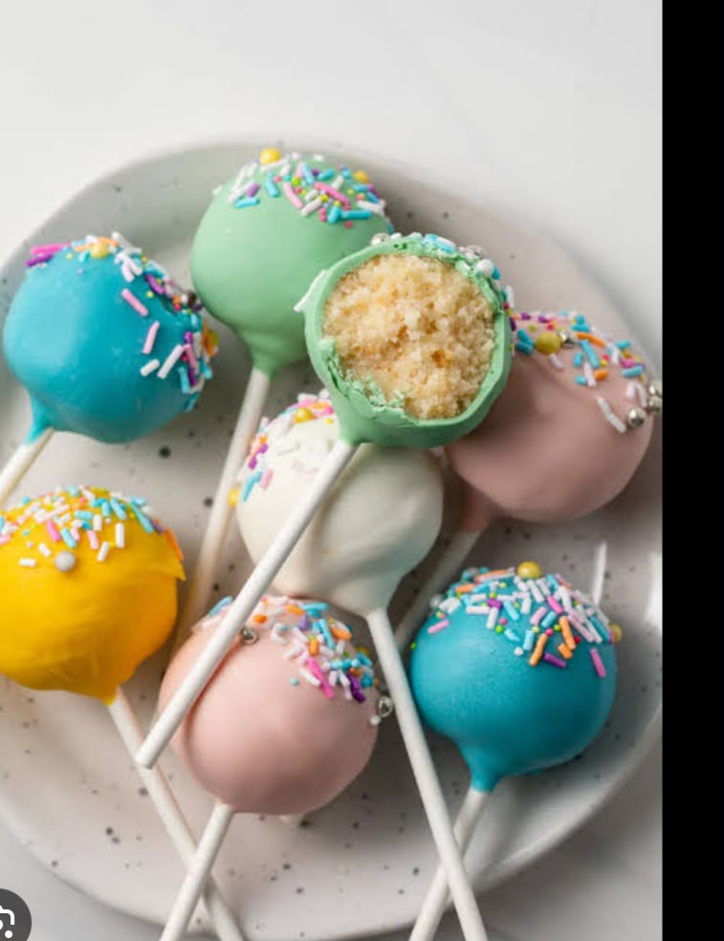
CAKE POPS FILLED WITH FLAVOUR
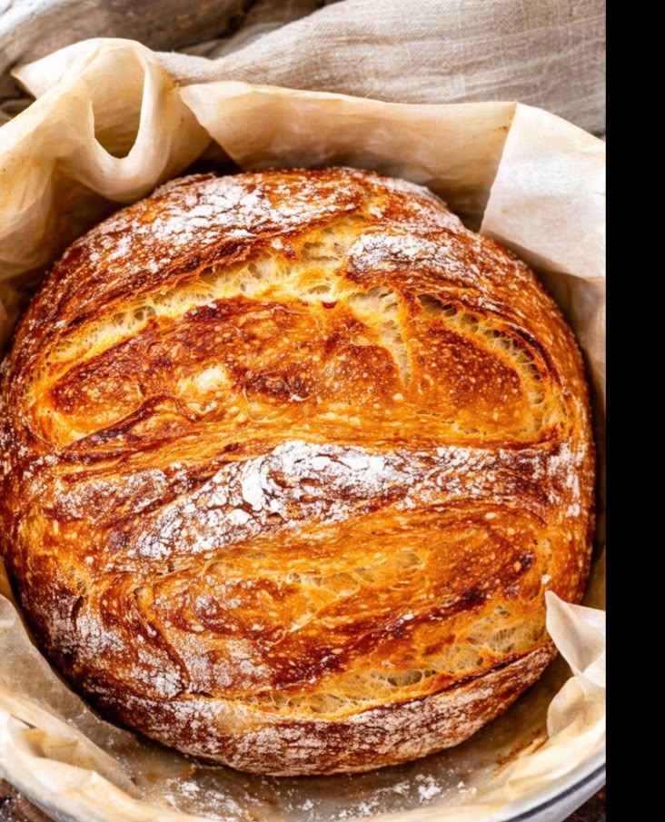
WHOLE GRAIN BREAD FRESHLEY BAKED WITH LOVE

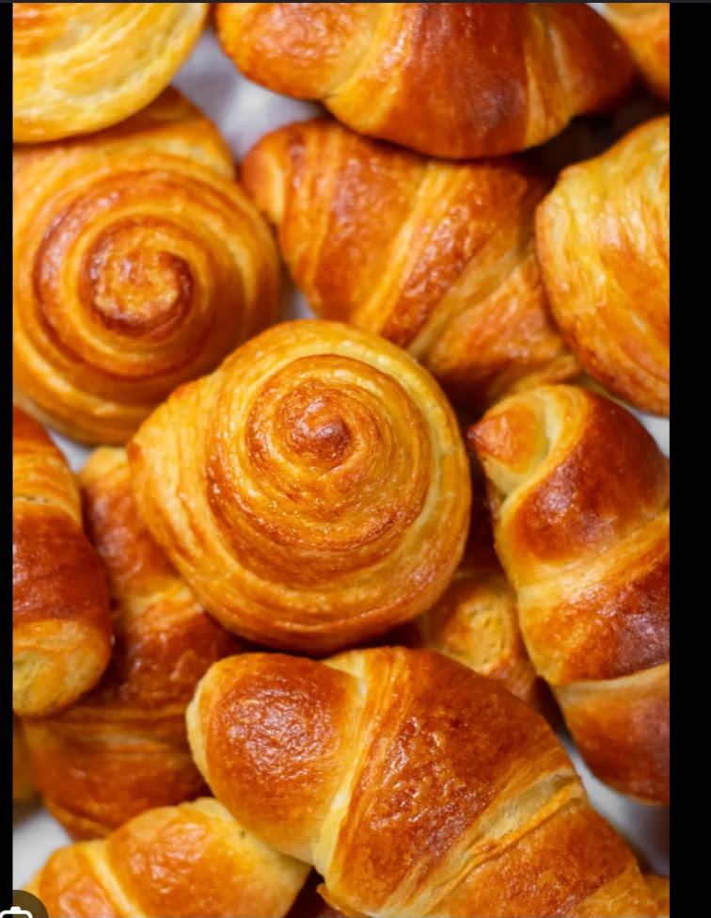

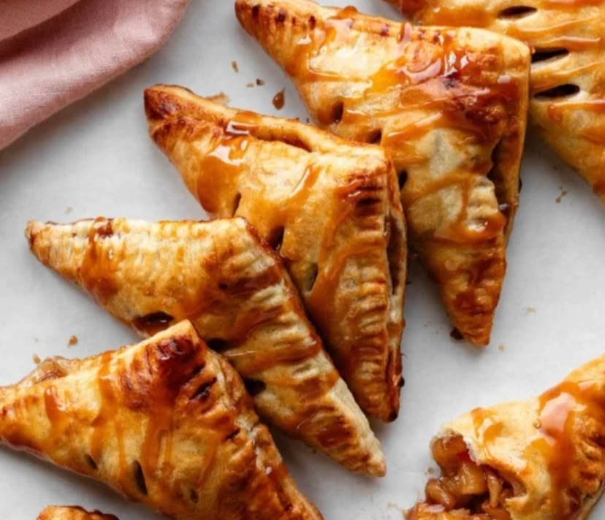

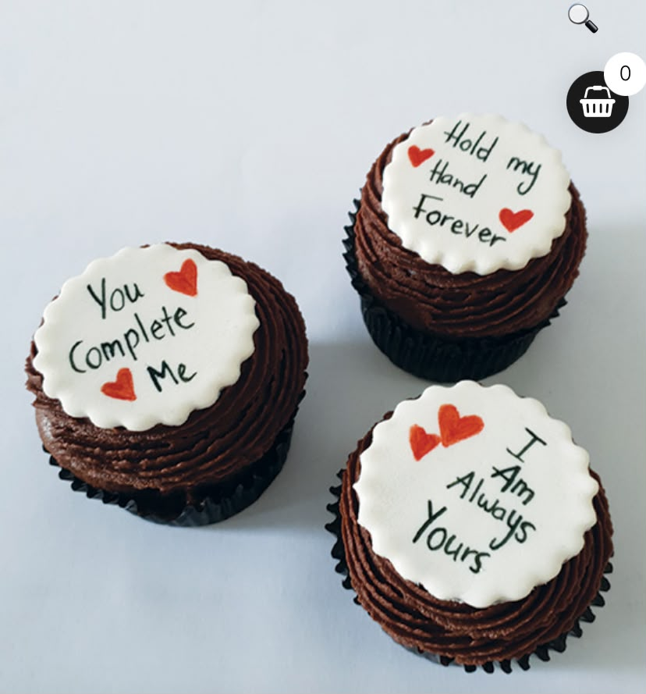

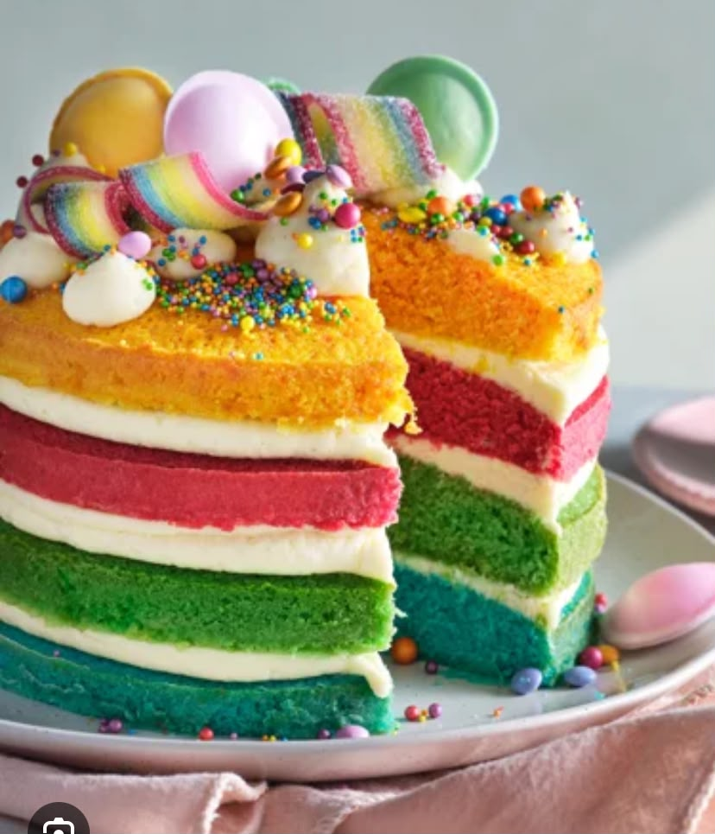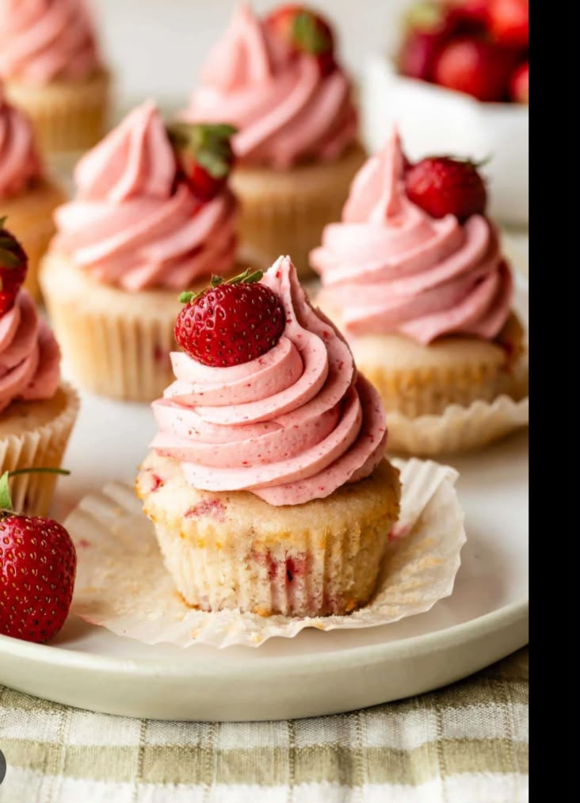

- REFERENCES
-Sweet Crumbs Pops Bakery. (2026)Sweet Crumbs Pops Bakery products and services
- Canva. (2026).Design inspiration and visual elements for bakery branding available at:
https://www.canva.com/
- W3schools.(2026).HTML,CSS and JavaScript documentation.Available at:
https://www.w3schools.com/
- MDN web Docs.(2025).HTML,CSS and JavaScript documentation
These references were used to support the planning,design and presentation of the Sweet Crumbs Pops Bakery website project.

